TSCA NEW CHEMICALS PROGRAM June 2010
Chemical Pre-manufacturing Notice Requirements
BACKGROUND
Section 5 of the Toxic Substances Control Act (TSCA) mandates that new chemicals and chemicals subject to significant new-use rules (SNURS) must be reviewed by EPA’s Office of Pollution Prevention and Toxics (OPPT) under New Chemicals Program prior to being manufactured, imported, or distributed in the United States.
Section 5(h)(3) of the TSCA allows the Administrator of EPA to develop regulations exempting manufacturers and processors of chemical substances subject to the TSCA from the notice requirements of section 5(a) if,
- They manufacture or process the substances "only in small quantities solely for the purposes of scientific experimentation or analysis or chemical research for the development of a product."
- No application is required for the exemption for R&D under section 5(h)(3).
- Procedural and recordkeeping requirements for the exemption have been promulgated at 40 CFR section 720.3(cc), section 720.36 and section 720.78.
The burden of proving eligibility for the R&D exemption is entirely with the person claiming it.
BOTTOM-LINE
EPA advises those claiming the exemption to be prepared to justify their claim to EPA in adequate detail. In addition to the specific requirements for the R&D exemption at 40 CFR section 720.36(c)(2), that if a company distributes an R&D substance outside of its employ it must
- Notify that the use is for R&D only and
- Provide notice of any health risk, please note that 40 CFR section 720.36(c)(3) establishes that adequacy of notification is the responsibility of the manufacturer.
- There is no bar to your being paid for a product which is for use in R&D.

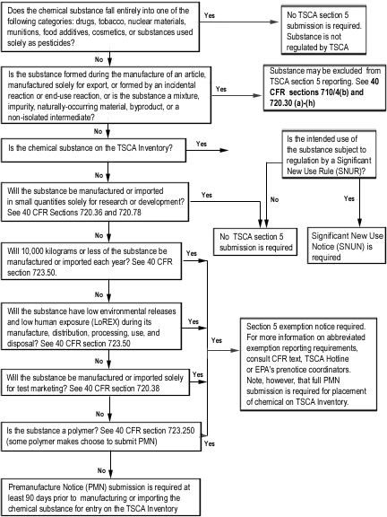
TSCA PMN Applicability Flowchart

