Using Apps.SMU on the Chrome browser
The Chrome browser will display the following, on your first login to http://apps.smu.edu. Click the Install button.
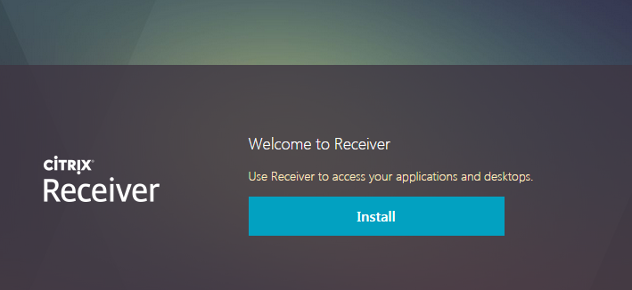

The next screen will say ‘we’re detecting if Receiver is already installed’, but the detection may not work correctly.
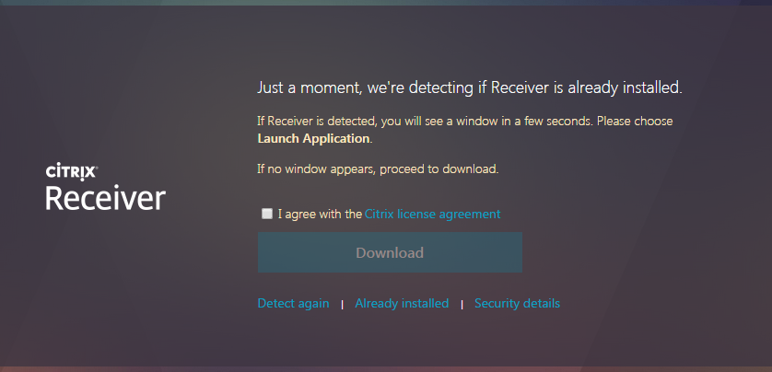

Check the box to agree to the license agreement. If you have used Apps.SMU on your device previously, click the Already installed link. If not, click the Download button.
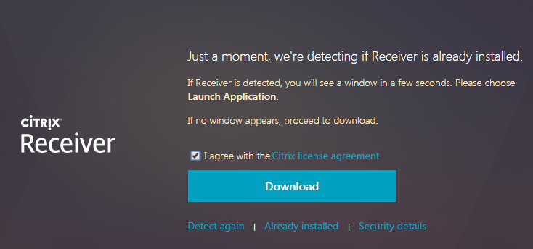

The next screen will look like this. Upon completion of the download. Click the file to install. When the installation completes, click the Continue button.
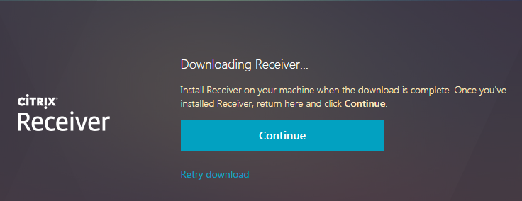

If the process to confirm the install does not work, click the Already installed link.
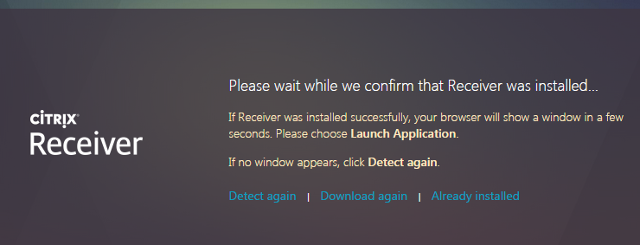

This completes the Chrome setup for Apps.SMU. You will see your favorites displayed if you have previously used Apps.SMU.

