**Using SQL Developer on Apps.SMU**

You may see a window like this on the first launch.  If you have any preferences available to import, highlight them and click ‘Yes’.  If not, click ‘No’.

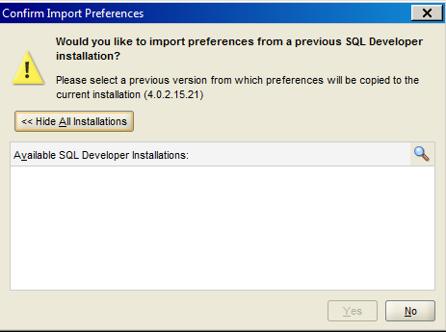

On first launch, clear the ‘Allow automated usage reporting to Oracle’ checkbox, and click OK.

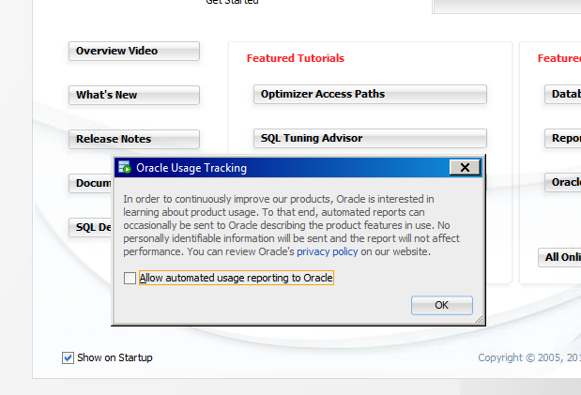

**CREATING NEW CONNECTIONS:**

From the Welcome Page, use the Database Connection pagelet to easily add any connections available to you by simply clicking the hyperlink of the database name.

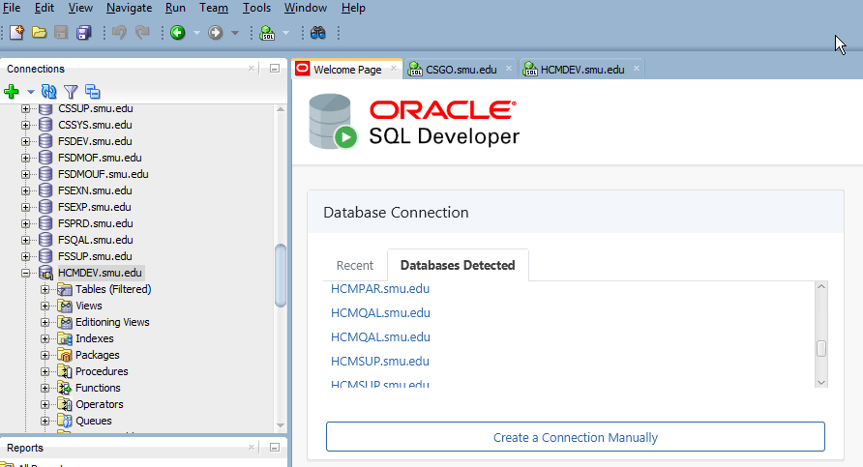

Now that you have a saved connection, you can double-click from the list of Connections, and input Username/Password to sign in. Do not save your password as part of the connection.