STATA on Apps.SMU

The STATA application functions the same on Apps.SMU as it does on a local client install. The key difference is that you will need to update your Do File (or other script) to change the path to the logs and data.

If you store your data set on your SMU provisioned U drive, that drive will be mapped and available. In that case you would write logs to and read data sets from U:\data (or whatever directory you choose to create on U). For instance, your script might include-> use “U:\data\auto.dta”

However, you may prefer to access data sets from a drive on your local device. In that case, launch the STATA application via Apps.SMU. Navigate to File, Change Working Directory, and then browse to the directory on your local device. Select the directory where your data set is stored, and choose OK.

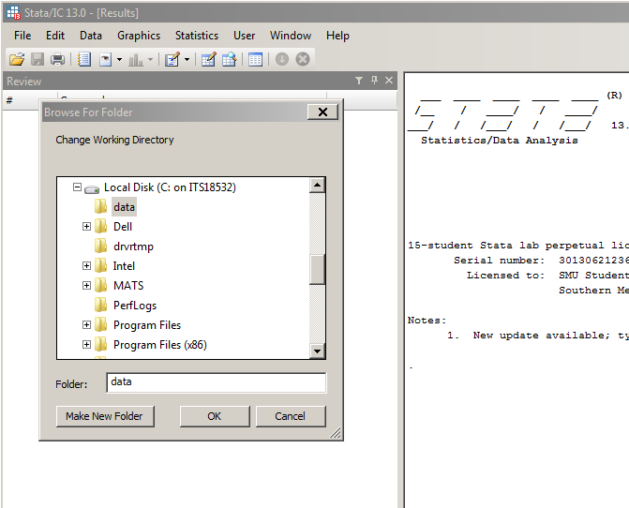

After clicking OK, STATA will run the cd command to that directory. It will look something like this:

cid:image003.png@01D05FD3.8E04ECD0

Now you can see how to reference your local drive in your script. In this case, your script might include-> use \\Client\C$\data\auto.dta

Looking for sample .ado files?

The sample .ado files can be accessed by choosing File, Open, and then browsing to *Vol_E (S:)* in the *Look in* box. Each file is in a folder named for the first digit in the file name. For example, to find a file called sqreg.ado, browse to *Vol_E (S:)*, and then look in the ‘s’ directory.

