How to install Cisco Ironport Email Security (Encryption) plugin

- Download the installer from:
https://smu.box.com/s/qf874l7p6qe9wy8twuo2lqkgq6r1st61
- Close Outlook and any open messages, appointments etc.
- Right-click, Run As Administrator
- Click OK
- Click Next
- Accept agreement, click Next
- Select “Custom…”, click Next
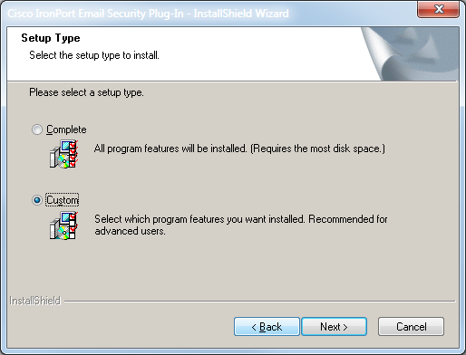
WARNING: Do not select “Complete”, otherwise you will be required to uninstall/reinstall!
- Keep the default destination, click Next
- Keep default features, click Next
- Select “Flag Encryption”, click Next
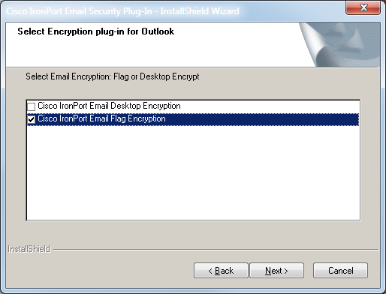
WARNING: Selecting “Desktop Encryption” will require uninstall/reinstall!
- Click Install
- Click Finish
- Open Outlook, go to File – Options (Outlook 2010), or go to Tools > Options > Cisco Email Security (Outlook 2007)
- Select Add-ins, Add-in options
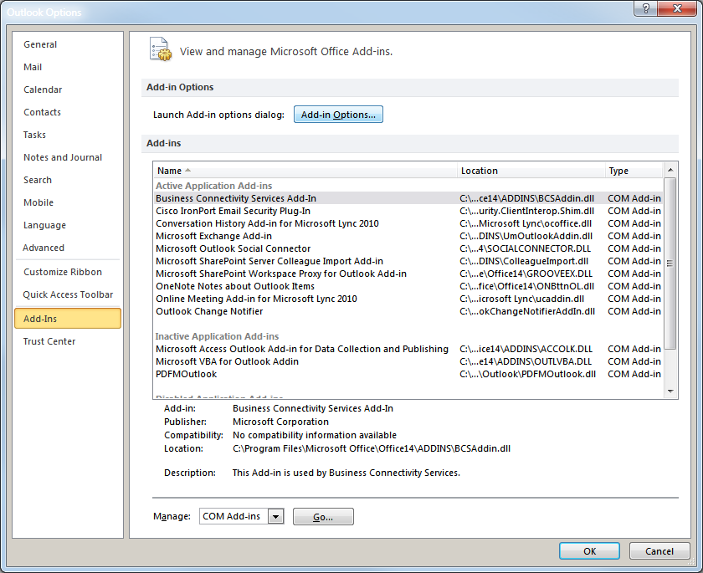
- Click Flag Encrypt Options and select Flag X-header
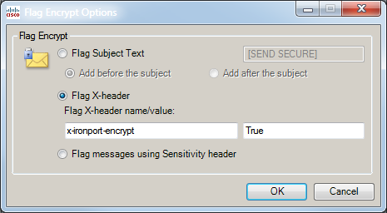
- Click OK twice.

