LOREA SEIDEL, M.Ed.
SPHR, Certified Dare to Lead™ Facilitator

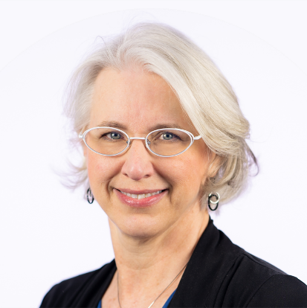
Lorea Seidel is the Chief People Officer for the Perot Museum of Nature and Science in Dallas, Texas. She also serves as principal for Aerie Leadership LLC serving as Leadership Development Consultant and Executive Coach. As an executive coach, she focuses on leaders and aspiring leaders aspiring to better understand and then build on their existing strengths, ultimately growing in their ability to lead with courage, confidence, and connection. Throughout her work, Lorea personally seeks to lead with inspired optimism, helping people move from obsessing over what’s problematic to envisioning what’s possible.

As both an internal leader and a consultant, she helps leaders develop braver, innovative, high-trust and high-performing teams. Her consulting expertise includes leadership and professional development, organizational assessment, strategic planning, change management, employee engagement, team dynamics and cohesion, culture building and employee retention.

As a seasoned facilitator, Lorea has delivered numerous workshops on a variety of professional development topics including:

- Dare to Lead™  - Leading at the Speed of Trust®  - 7 Habits of Highly Effective People®  - 6 Thinking Hats®  - The Leadership Challenge® | - Introduction to StrengthsQuest®  - Strengthsquest: Putting Your Strengths to Work®  - Strengths-Based Team Leadership  - Getting the Feedback You Need Right Now  - Managing and Coaching for High Performance
Lorea has more than 20 years of experience working across all areas of Human Resources. In addition to her work with the Perot Museum, she has held leadership roles in both for-profit and non-profit entities including Southern Methodist University (SMU). She held a director role in SMU’s Department of Human Resources and has served as an adjunct faculty member in both the Simmons School of Education and Cox School of Business. She has also taught workshops for SMU’s Executive Education Program.

Lorea holds a bachelor’s degree in Public Relations, a master's degree in Community Counseling and has completed additional graduate work focusing on psychology at work and executive coaching. Lorea is certified as a Senior Human Resources Professional (SPHR) through HRCI. She was trained by Dr. Brené Brown to become a Dare to Lead™ Facilitator, one of approximately 700 certified facilitators around the world. She is excited to share this impactful content and curriculum with her consulting and coaching clients. Lorea is also working to become a certified Positive Intelligence coach and provides this highly engaging mental fitness program to both organizations and individuals in the community.

