SMU –in –Taos Off Campus Crime Alert

SMU in Taos Employee Suspect in Fatal Stabbing

The Taos County Sheriff’s Department is investigating the fatal stabbing of a 22 year old man that occurred late Friday night, June 19, 2015 in the town of Penasco. SMU employee Manuel Videl Leyba, is being sought for questioning, as a possible suspect, in connection with this incident.

The Sheriff asks anyone with information regarding Leyba’s whereabouts to contact Taos Central Dispatch by calling (575)758-2216 or to submit a tip anonymously through Taos County Crime Stoppers by calling (575)758-HALT.

Authorities offer the following safety tips:
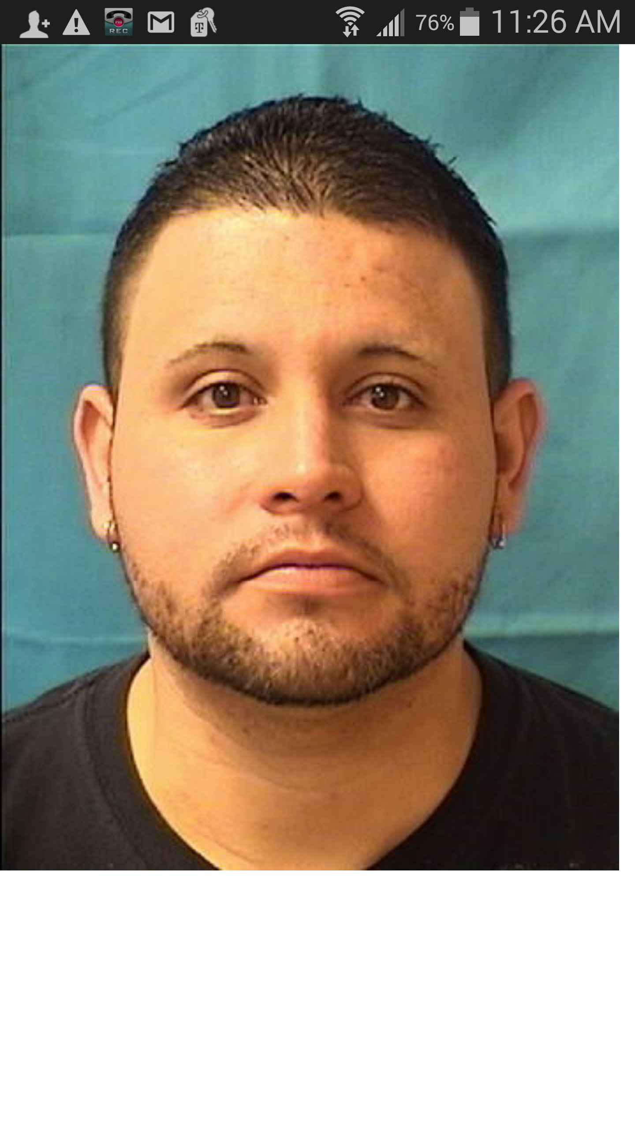
• Always be aware of your surroundings, especially in parking lots and isolated areas.
Have your keys ready as you approach your car and lock your doors after entering.
• If you witness a crime, or see something suspicious, call police immediately at 911.
Time is of the essence in such situations.
• If you go out with friends, leave with your friends. Friends keep an eye out for each
other at all times. Don't let a friend leave alone.
• Have a secret "help" signal with friends if you don't feel comfortable with someone at
a club or bar.
• Don’t prop open self-locking doors.
• Lockable doors in your casita room should be locked.
• Stay on paved roads and highways when driving outside of the SMU-in-Taos campus.
• Watch your keys. Don’t lend them. Don’t leave them. Don’t lose them. And don’t put your name and address on the key ring.

