Curriculum Tags
What are curriculum tags?
- Catalog Level Tags (2012/2016 Foundation, 2012 Pillar, 2016 Breadth, 2016 Depth)
  - Added at the catalog level by the Registrar’s Office, and will automatically appear on scheduled sections in the Class Attributes fields.
- Section Level Tags (2012/2016 Proficiencies and Experiences)
  - After approval from the UC office, tags are added at the section level, using the Class Attributes fields, by department schedulers.
  - Proficiencies and Experiences (PREX) tags include:
Component | Component Description | Curriculum Component Tag | Tag Description
PREX | 2012/2016 Proficiencies and Experiences | CE | 2012/2016 Community Engagement
PREX | 2012/2016 Proficiencies and Experiences | GE | 2012/2016 Global Engagement
PREX | 2012/2016 Proficiencies and Experiences | HD | 2012/2016 Human Diversity
PREX | 2012/2016 Proficiencies and Experiences | IL | 2012/2016 Information Literacy
PREX | 2012/2016 Proficiencies and Experiences | OC | 2012/2016 Oral Communication
PREX | 2012/2016 Proficiencies and Experiences | QR | 2012/2016 Quantitative Reasoning
PREX | 2012/2016 Proficiencies and Experiences | WRIT | 2012/2016 Writing

How do I add PREX tags to sections?
- Confirm tag approval by checking General Education Website - http://www.smu.edu/academics/officeofgeneraleducation/universitycurriculum/ForFacultyandStaff/CourseProposals
  - Shows approval status. Only add tags to sections that have been approved, not proposed.
- Confirm with Faculty teaching the course
  - Just because a section is approved to be offered with a PREX tag doesn’t mean that the professor teaching that section will elect to teach it with the criteria necessary to receive the approved tag. This could vary on a term by term basis.
- Run a query to verify what tags may have “rolled” from a previous term.
- Add/Delete necessary PREX tags in the Class Attribute fields on the Basic Data page of the Schedule of Classes.
Running a Class Attribute query to verify tag set up
- Navigate to: Reporting Tools > Query > Query Viewer

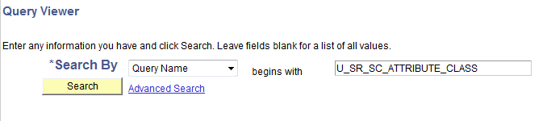
- Enter Query Name U_SR_SC_ATTRIBUTE_CLASS and click on Search

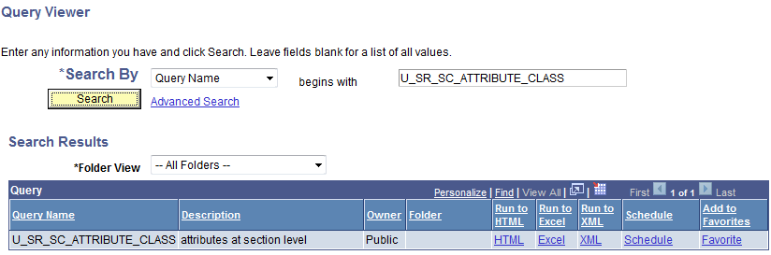

- Click on the Excel link under Run to Excel

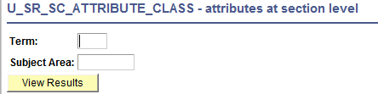

- Enter the term and Subject Area Prefix information and Click on View Results
- Excel spreadsheet will open with all sections for the selected subject area that have tags set up. Please note that many sections can have multiple tags.
Adding PREX tags in the Schedule of Classes
- Navigate to Curriculum Management > Schedule of Classes > Maintain Schedule of Classes. Enter your term and subject information and open a section in which you need to add/delete a tag.
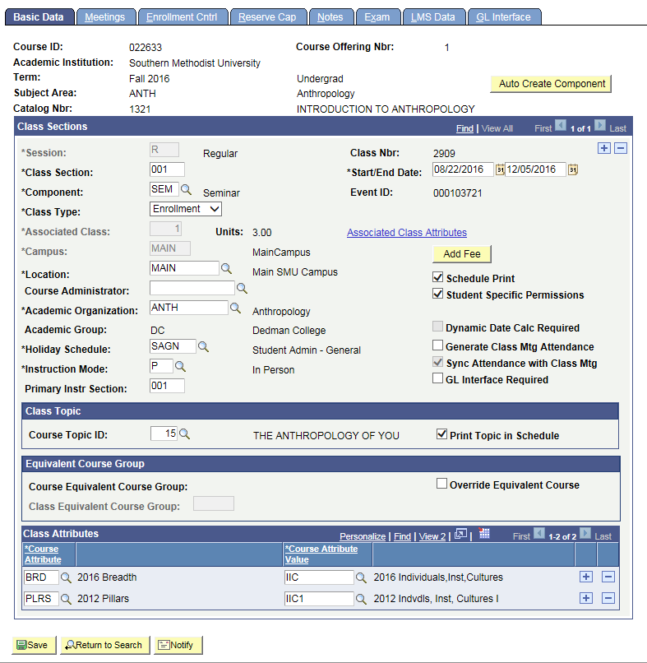
- Tags (Class Attributes) may already be in place on sections. Catalog level tags should automatically appear on sections.

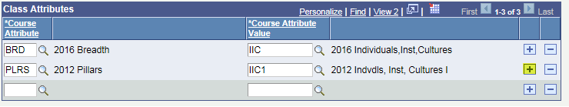
- To add an additional tag, add a row by clicking on the plus sign icon on the previous row. A new blank row will appear.
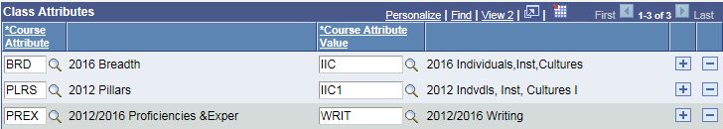
- Then type the approved tag information into the appropriate boxes. If you are unsure of the correct tag codes, the magnifying glass icon next to each box can be used to look up available tag information.
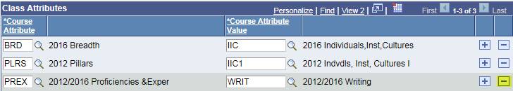
- To delete a PREX tag from a section, click the minus sign icon. You cannot delete any catalog level tags from sections.
- Be sure to save your work before navigating away from the page.
- Don’t forget to check on all scheduled sections as tags will need to be added on a section by section basis.

