Using the SMU_Guest Network
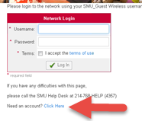
- Locate the WiFi settings on your device
- Connect to SMU_Guest
- Launch a web browser (Firefox, Safari, Chrome or Internet Explorer)
- If the portal page does not appear, type in a web address such as smu.edu and hit enter. You should then be redirected to the portal page.
- If you do not have an account on the guest network, click the link next to “Need an account?”
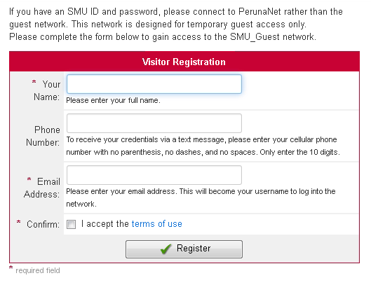
- (Required)Enter your name in the Name Field
- (Optional) If you’d like to receive your password via text message, enter your cellular phone number in the Phone Number field (ex: 2147682000)
- (Required) Enter a valid email address in the Email Address field
- Check the box to accept the terms of use
- Click Register
- You will see a confirmation page. Click the link to Login
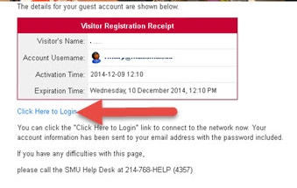
- Login using your temporary credentials
  - Enter the email address you provided as your username
  - Enter the password provided in the email or text message confirmation
  - Check the box to accept the terms of use
  - Click Login

Your credentials are valid for 24 hours only. After that time, you will need to repeat the provisioning process as outlined above. If you will be on campus for longer periods of time, an existing faculty or staff member can request a guest account with a longer expiration through the IT Help Desk or from a local technology support resource.

