**Using SQL Developer on Apps.SMU**

On the first launch you may see this error:

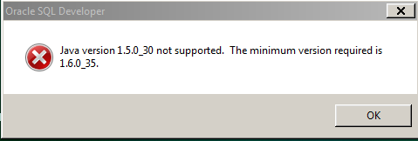

Click OK, and copy E:\Java\jdk1.7 into the next window:

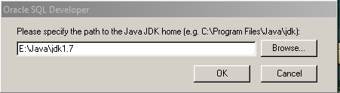

Click OK, and SQL Developer will open.

You may see a window like this.  I do not anticipate that you will have preferences available.  If you have any preferences available to import, highlight them and click ‘Yes’.  If not, click ‘No’.

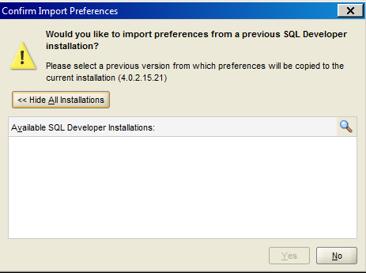

On first launch, clear the ‘Allow automated usage reporting to Oracle’ checkbox, and click OK.

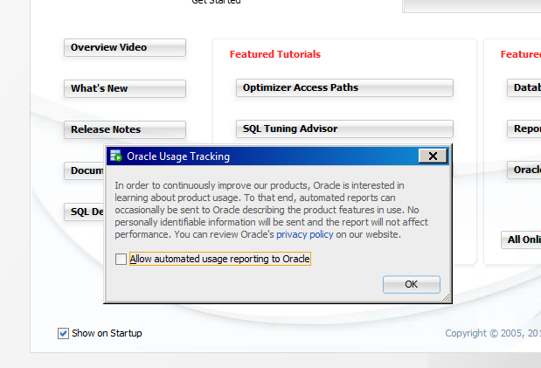

If you have used a previous version of SQL Developer on Apps.SMU, you may have saved connections. If so, follow the IMPORTING SAVED CONNECTIONS steps. If not, skip to CREATING NEW CONNECTIONS.

**IMPORTING SAVED CONNECTIONS:**

Please right-click the Connections icon, and choose to import connections.

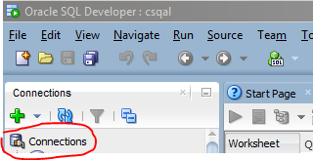

From there, browse to the following directory on your U drive, and double-click the connections.xml file.

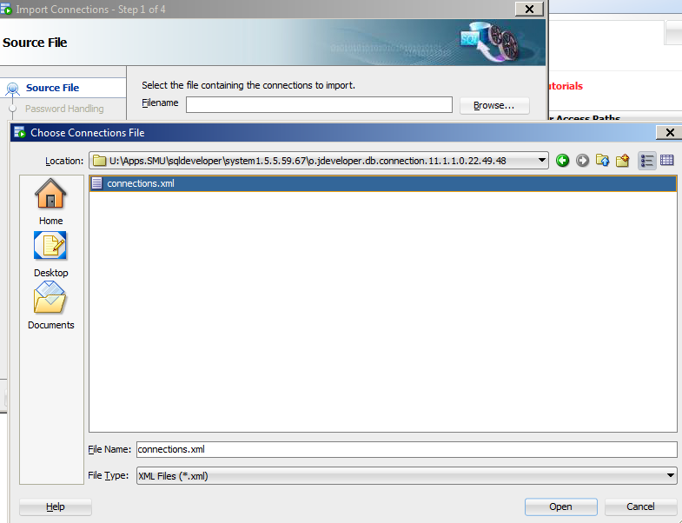

Choose Next.  Check the box next to connections.xml to select all of your connections, and choose Finish to complete the process.

**CREATING NEW CONNECTIONS:**

Click the ‘+’ under Connections.

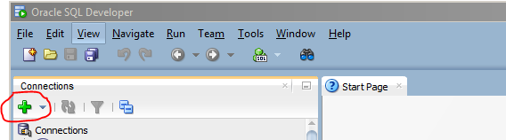

Type the name of the DB you will connect to in the Connection Name field, change the Connection Type field by dropping down and choosing TNS, and then drop down on the Network Alias field and choose your database. You may populate the Username field, but DO NOT populate the Password field. Click the Save button.

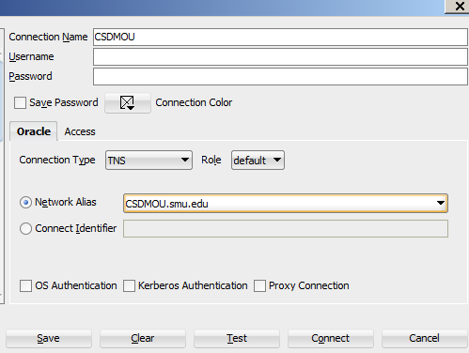

Now that you have a saved connection, you can double-click from the list of Connections, and input Username/Password to sign in.