FACULTY PAY SCHEDULE ELECTION
Please contact the Department of Human Resources if you want additional assistance (smuhr@smu.edu or 8-3311).

Steps to complete your online election

- Login to my.smu.edu with your SMU network user name (SMU ID number) and password.

- Switch to the Employee Self Service homepage by clicking at the top of the page and choosing that option.

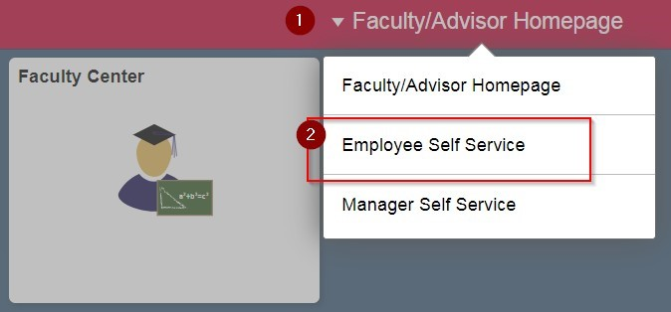
3.

Click the Faculty Pay Schedule Election tile.

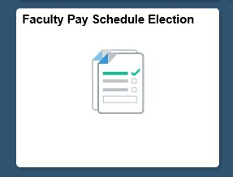

NOTE: This tile will only be visible from April 1st – 30th.

- ‘Add Faculty Pay Election Form’ page will open for election by default if you are logging in through desktop. For handheld devices, select ‘Add Faculty Pay Election Form’ by clicking on the options available.
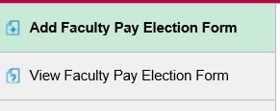

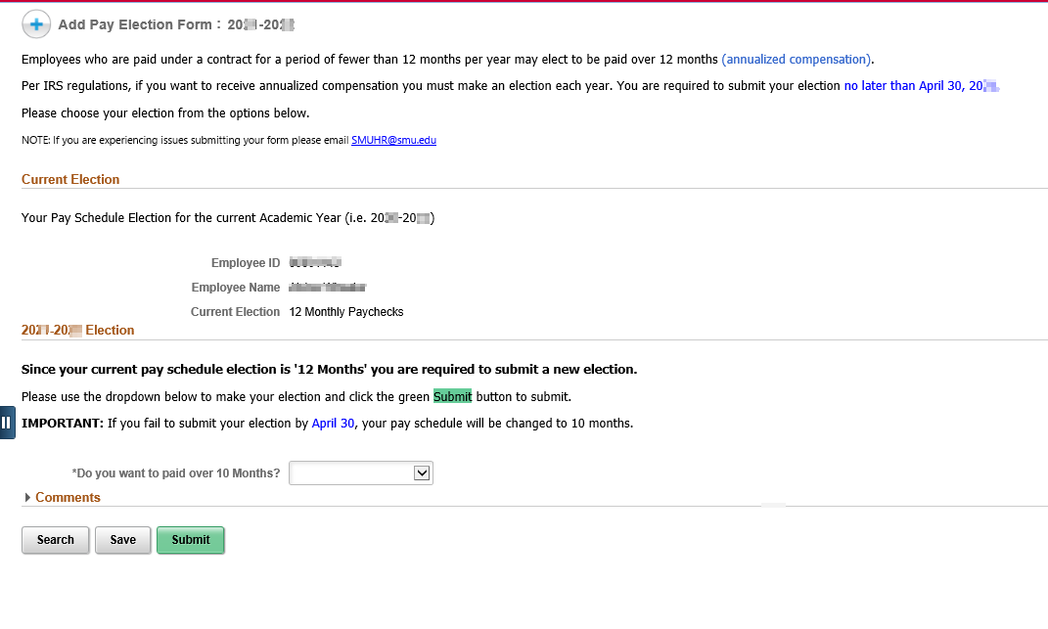
- Current Election section will show your election for current academic year

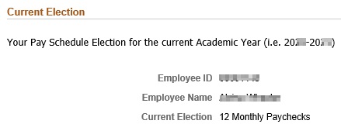

- To make your new election for the upcoming academic year, select an option using the dropdown available in the next year’s election section.

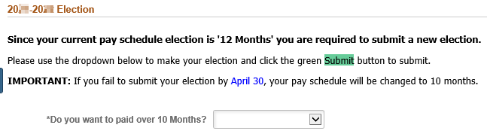

- You must confirm your election using the ‘I Confirm’ check box.

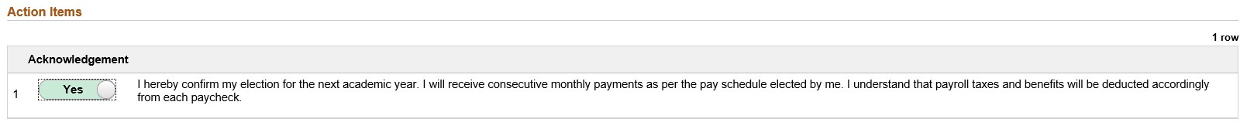

- Click 'Submit.' You must click the green Submit button to finalize your election.

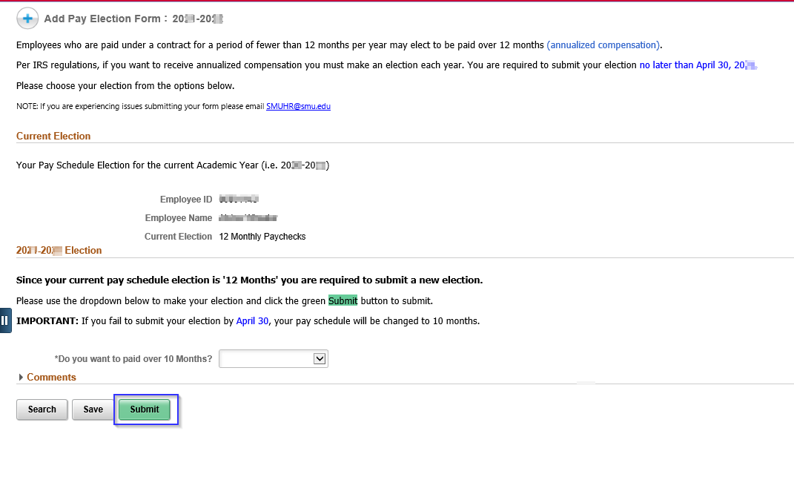

Your election is not finalized until you click Submit. This is a required step for the pay
schedule election process.
NOTE:
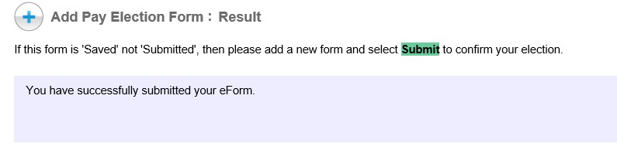

9.

A
confirmation window appears.

10. You will receive a confirmation email from the Department of Human Resources (SMU HR) that your election has been received.
